In this video Teacher want to quickly show and demonstrate the environment and interface of Natron. When you first opened Neutron then you will see below

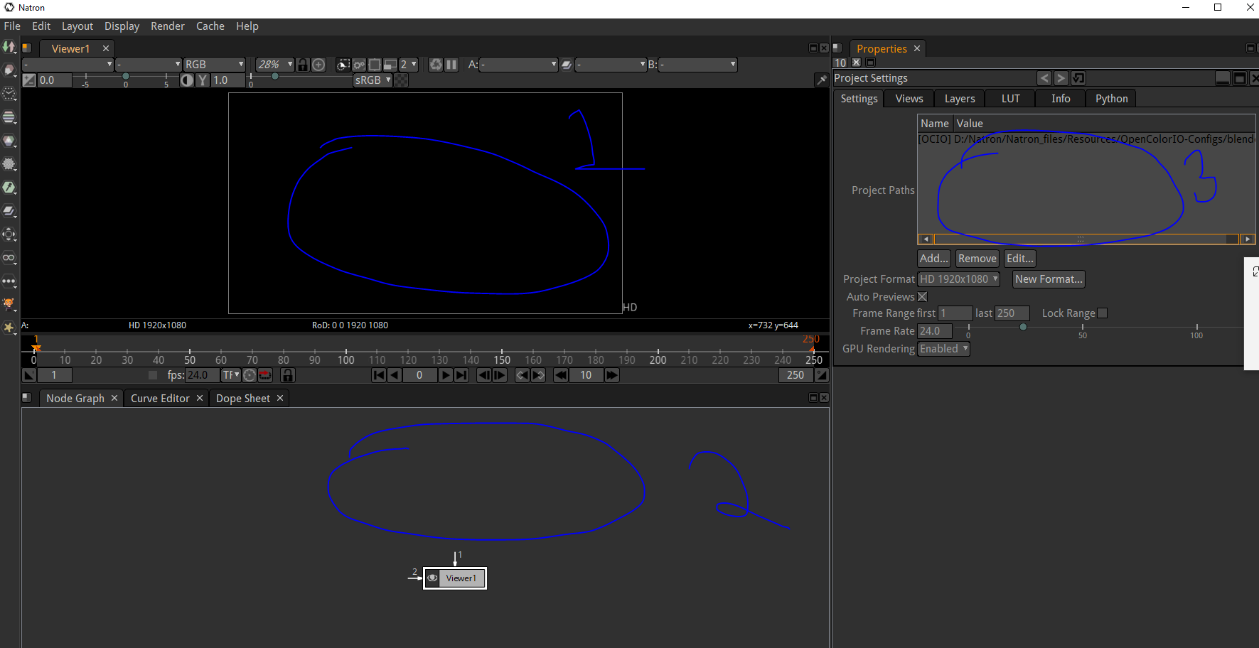
In marked 1 is Viewer window
In marked 2 is Node graph and in marked 3 is Setting of the Project
You can set the output format in our project settings
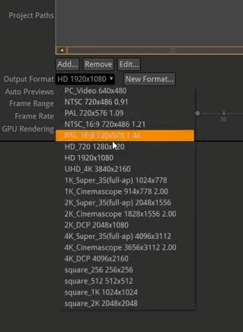
The output format tell us what type of output you want (I think it's dimenstion , aspect ratio)
and whatever format you choose the viewer window will show the video preview in that format

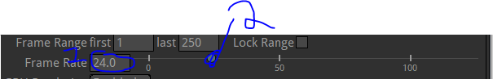
We can set the frameRate by using the circular handle as marked 2in our project setting as shown above we can also type on it by clickin on the handle aas marked 1 above
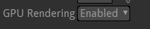
GPU rendering is enabled(I think that by this graphic processing will be done by the GPU) in Project settings and in settings tab

In our Viewer window you can see our timeline as marked below where our frames are shown
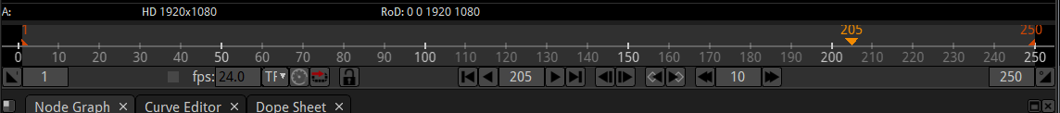
We can click in the middle of the timeline to go towards that frame
We can set the frame range in our project setting as marked below
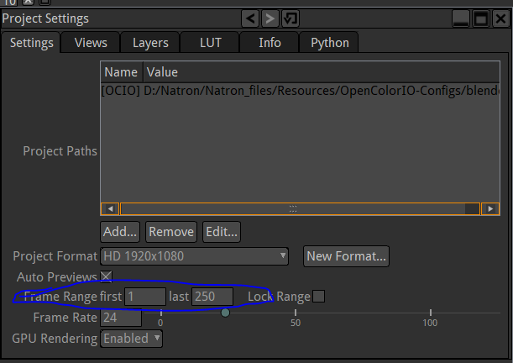
We can set the starting frame number in first field and the last frame in the range in the second field

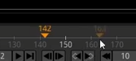
In timeline the orange triangle is where we are now and we can reach to frame by clicking on it in the timeline Now in dim orange which you see when you hober over the timeline tells that could be your frame if you click here
The above are teh viewer window controls and they are self explanatory so i will not elaborate it but is the teacher teaches us about it later then we will discuss them

I think we can add a background in our viewer window
We have many predefined background like checkerboard
We can go to the marked below and then in submenu click on checkboard
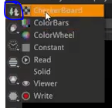
and now in the node graph window
we have now two node instead of one node that is viewer node I think in that node whatever is connected to it will be shown in the viewer window
and we have checkerboard node
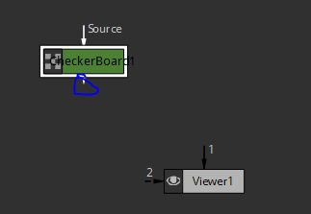
we can connect one node to another by dragging from marked 1
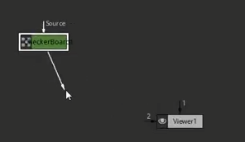
and then connect it to targeted node in this case it is CheckerBoard Node by dragging it over the targeted node
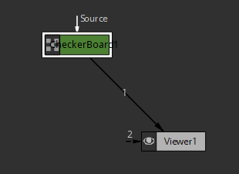
Now our viewer window will look like below
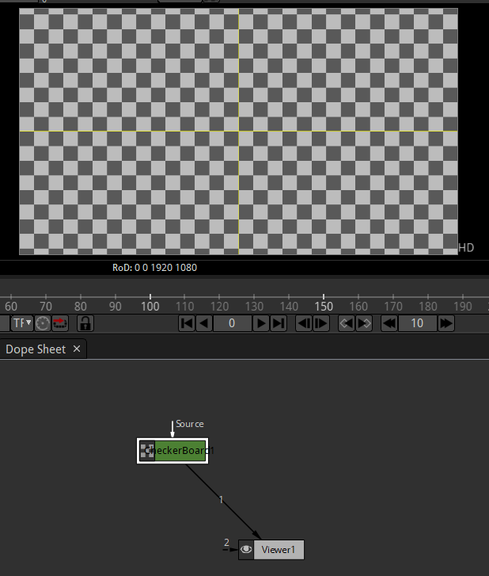
Now if we play our viewer window then it will just show the checkerboard screen only nothing else
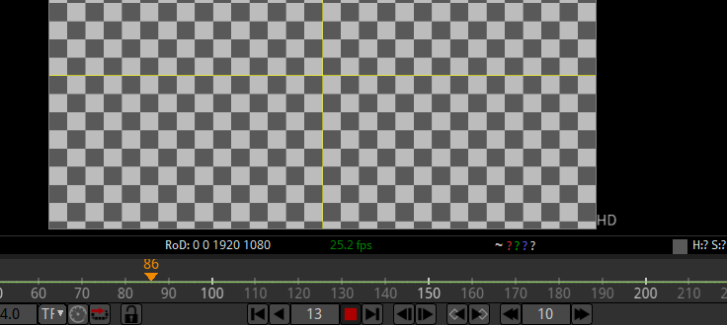
Note:-
All the settings like Project Settings and configuration related to a node is given in Properties window
Now you can see the configuration of checkerboard
as shown below inside the Properties settings
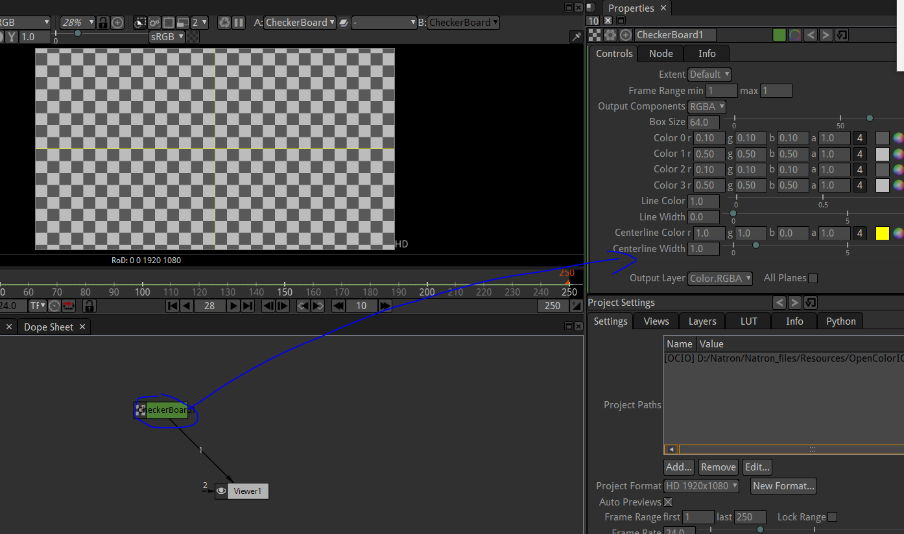
you can control the size of the boxes in checkerBoard
in the checkerboard setting
by using the box size as shown below
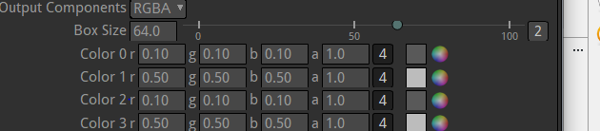
You can also set the color of the boxes
Each color represents the set of boxes in a set of columns and both repeat after leaving one column or box
and now checkerboard setting three are two other setting to conrol this checkbox
which are Node and info other than controls as shown below
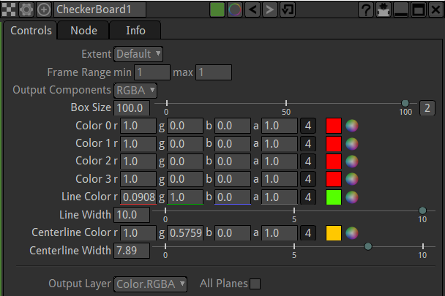
If you have not done anything with nodes don't worry we are gonna go througha lots of experience
you gonna get very comfortable It is a very powerful way to do editing and this natron is node based editor so you have to learn this node based graph

To disconnect a node drag any part of the pipe connecting the node then the connection will be broken

Whatever node is connected to the viewer node will be shown in viewer window
Note:-

If your node setting in properties window gets removed by mistake then you can bring it back in the properties window by double clicking on the node in node graph
Scroll up and down in the viewer window to zoom in and zoom out in the viewer
You can move around in the viewer by dragging by the scroll in mouse
to comnnect two node you can drag from viewer to node or from node to viewer

Now whenever you open a neutron and add your first node then in node graph it will be connected by default to the viewer node

Now you can also do something like when you make a node then it become an intermediate node in the connection of nodes or become a child node of a one node and that one node is indirectly connected to previous node
So for that select the node which you want to make parent of new node and then create ne node
Its structure will be like below
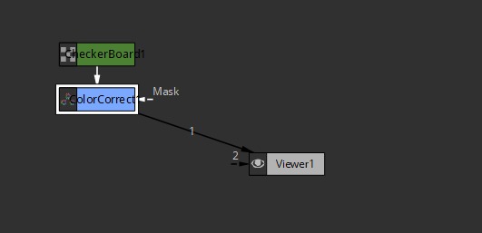
Now you can see that theh colorcorrect node is inline between
If it did not work in line then we willl conect these nodes manually
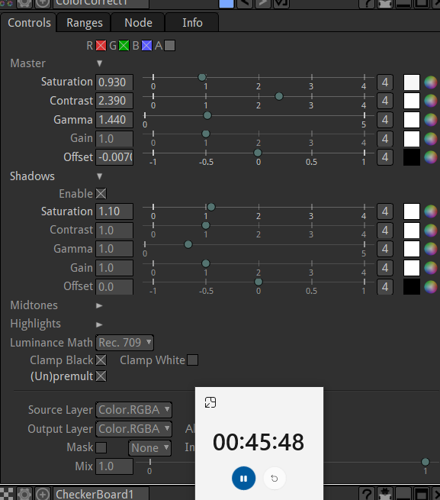
With the help Color correct node we can increase the saturation, contrasr or Gamma as shown above in propertoes window
We can do lots of thing but it isjust a checkerboard
So this is basic example of how this is working
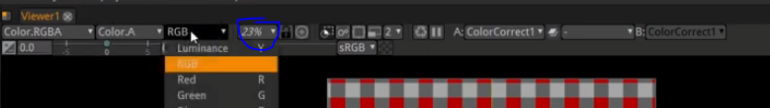
We have more option in Viewer window to see what we are viewing who knows
By marked you can do zoom in or zoom out manually without scrolling
and we will do more wth these option in viewer with these later tutorials
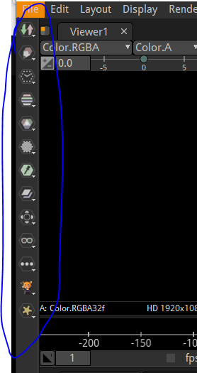
Now in the left side of the window we have nodes you can add to the node graph categorised under menus as marked above
If you hover over them then in the tooltip you will know what type of node contains in the hoverred menu
Its menus contains type of nodes in the manus like time , draw , image nodes , merge , filter

So differnt type of nodes do differemnt type of things
Not every node can be connectted to other node
there's different way to create different nodes for different things
we will see that again in next lessons
whatever node you double click on the node and its properties will come in the top of the previous window
IN next lesson we may start with compositing with natron

